A Major Project Report

On

**Online Canteen Automation System**

*Submitted in partial fulfillment of the requirements for the award of the degree of*

**BACHELOR OF TECHNOLOGY**

IN

**COMPUTER SCIENCE AND ENGINEERING**

**BY**

**Mr. P. RAJEH (16M31A0544)**

**Mr. S. GOWTHAM KUMAR REDDY (16M31A0561)**

**Mr. K. SIVA KUMAR(16M31A0530)**

Under the supervision of

**Mr. T. SUNIL KUMAR**

**ASSOC.PROF**

DEPARTMENT OF COMPUTER SCIENCE AND ENGINEERING



**DEPARTMENT OF COMPUTER SCIENCE AND ENGINEERING**

**SPHOORTHY ENGINEERING COLLEGE**

**(AFFILIATED TO JAWAHARLAL NEHRU TECHNOLOGICAL UNIVERSITY HYDERABAD)**

**NADARGUL (V), BALAPUR (M), RANGAREDDDY (D) – 501 510,**

**TELANGANA, INDIA**

**2019-2020**

**DECLARATION**

We, the undersigned, declare that the project title “**ONLINE CANTEEN AUTOMATION SYSTEM**” carried out at “SPHOORTHY ENGINEERING COLLEGE” is original and isbeing submitted to the Department of COMPUTER SCIENCE AND ENGINEERING, Sphoorthy Engineering College, Hyderabad towards partial fulfilment for the award of Bachelor of Technology.

We, declare that, the result embodied in the Project work has not been submitted to any other University or Institute for the award of any Degree or Diploma.

**Date:**

**Place: Hyderabad**

**Mr. P. RAJESH (16M31A0544)**

**Mr. S. GOWTHAM KUMAR REDDY (16M31A0561)**

**Mr. K. SIVA KUMAR(16M31A0530)**

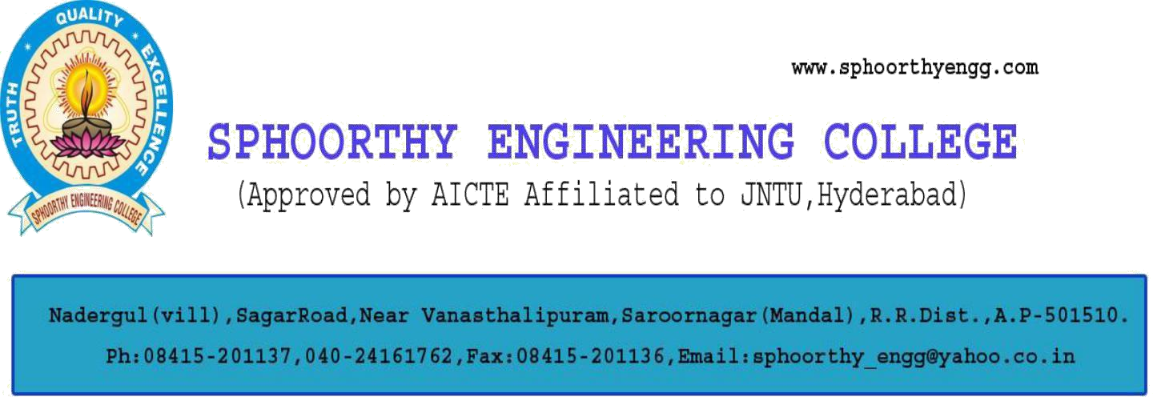

**DEPARTMENT OF COMPUTER SCIENCE AND ENGINEERING CERTIFICATE**

This is to certify that project entitled “**ONLINE CANTEEN AUTOMATION SYSTEM**” is a bonafide work carried out byMr. P.RAJESH(16M31A0544), Mr. S.GOWTHAM KUMAR REDDY (16M31A0561), Mr. K.SIVA KUMAR(16M31A0530) in partial fulfilment for the award of Bachelor of Technology in Computer Science and Engineering, Sphoorthy Engineering College, Hyderabad under the supervision or guidance of “Mr. T.SUNIL KUMAR”. The result embodied in the Project Work has not been submitted to any other University or Institute for the award of any Degree or Diploma.

**INTERNAL GUIDE** **HEAD OF DEPARTMENT**

**EXTERNAL EXAMINER** **PRINCIPAL**

**ACKNOWLEDGEMENT**

I express my deep sense of gratitude to my Project Guide Mr. T.Sunil Kumar (Assoc.Prof), Department of Computer Science & Engineering, Sphoorthy Engineering College, Jawaharlal Nehru Technological University Hyderabad (JNTUH), Hyderabad for his inspiring guidance, consistent encouragement, constructive criticism and helpful suggestions during the entire course of my research work.

I express my sincere thanks to **Dr. R. Ashok Kumar,** Professor & Head of the Department, Department of Computer Science & Engineering, Sphoorthy Engineering College, Nadargul (V), Balapur (M), Rangareddy (D) for his encouragement which helped me to complete my Project work.

I deem it a great privilege to express my profound gratitude and sincere thanks to **Mr. Chalama** **Reddy,** Chairman, **Mr. Jagan Mohan Reddy,** Secretary, **Prof. MVS Ram Prasad,** Director, **Prof. K.S. Shahji,** Principal, Sphoorthy Engineering College, Nadargul (V), Balapur (M),Rangareddy (D), for their moral support and help in the completion of my research work.

I express my heartfelt thanks to Professors, Associate Professors, Assistant Professor and other professional non-teaching staff of Department of Computer Science and Engineering, Sphoorthy Engineering College, Nadargul (V), Balapur (M), Rangareddy (D) for providing the necessary information pertaining to my research work.

**BATCH: 2016-2020**

**Mr P.RAJESH(16M31A0544)**

**Mr K.SIVA KUMAR(16M31A0530)**

**Mr S.GOWTHAM KUMAR(16M31A0561**

**)**

**ABSTRACT**

The Project “**Online Canteen Automation System**” enables the users to register online, read and select the food from e-menu card and order food online by just selecting the food that the user want to possess using their Browsers. The results after selecting the food from the E-menu card will directly appear on the screen near the Admin or the Manager who orders chef to cook Food. By using this application, the work of the waiter is reduced and that we also can say that the work is nullified.

The benefit of this is often that if there's a rush within the Canteen then there'll be chances that the waiters will be unavailable and therefore the users can directly order the food to the chef online by using this application. The user will have a username and a password, by using which they will login into the system. this suggests that the customer is that the regular user of the Canteen. The manual system involves paperwork within the sort of maintaining various files and manuals. Maintaining critical information within the files and manuals is filled with risk and a tedious process. Including a framework showing the way to apply Internet technology progressively as skills and confidence grow, the project demonstrates the route from adapting materials to developing a web environment.

# INDEX

|  |  |
| --- | --- |
| **Topics of content** | **Page numbers** |
| DECLARATION | i |
| CERTIFICATE | ii |
| ACKNOWLEDGEMENT | iii |
| ABSTRACT | iv |
| LIST OF FIGURES | vii |
| LIST OF SCREENSHOTS | viii |
| CHAPTER 1-INTRODUCTION | 1 |
| 1.1 Existing System | 2 |
| 1.2 Proposed System | 2 |
| CHAPTER 2-LITERATURE SURVEY | 3 |
| CHAPTER 3-SYSTEM REQUIREMENTS | 5 |
| 3.1 Hardware requirements | 5 |
| 3.2 Software requirements | 5 |
| CHAPTER 4-FEASIBILITY STUDY | 6 |
| 4.1 TECHNICAL FEASIBILITY | 7 |
| 4.2 ECONOMIC FEASIBILITY | 7 |
| 4.3 SCHEDULE FEASIBILITY | 7 |
| 4.4 OPERATIONAL FEASIBILITY | 7 |
| 4.5 MARKET FEASIBILITY | 8 |
| 4.6 PROCESS MODEL | 9 |
| CHAPTER 5-SOFTWARE REQUIREMENT ANALYSIS | 11 |
| 5.1 PURPOSE | 11 |
| 5.2 OVERALL DESCRIPTION | 11 |
| 5.3 USER INTERFACES | 13 |

**v**

5.4 SOFTWARE QUALITY ATTRIBUTES 15

CHAPTER 6-SYSTEM DESIGN 16

* + 1. Class Diagram 17
    2. Use case Diagram 18
    3. Activity Diagram 19

CHAPTER 7-SOFTWARE ENVIRONMENT 20

CHAPTER 8-IMPLEMENTATION 23

8.1Source code for updating cart in website 23

8.2Source code for Database Connection 24

CHAPTER 9-SYSTEM TESTING 25

9.1Introduction 25

9.2Types of tests 25

9.3Testing Objectives 27

CHAPTER 10-SCREEN SHOTS 28

CHAPTER 11-CONCLUSION 33

CHAPTER 12-SCOPE FOR FUTURE DEVOLOPMENT. 34

CHAPTER 13-BIBLIOGRAPHY 35

**vi**

# LIST OF FIGURES

|  |  |  |
| --- | --- | --- |
| **Figure** | **Title Page** | **Page no’s** |
| 4.6.1 | Process Model | 12 |
| 6.1.1 | Class Diagram | 21 |
| 6.1.2 | Use case Diagram | 22 |
| 6.1.3 | Activity Diagram | 23 |

|  |  |  |
| --- | --- | --- |
|  | **LIST OF SCREENSHOTS** |  |
| **Figure** | **Title** | **Page no’s** |
| 10.1 | Home Page | 28 |
| 10.2 | Manager Control panel | 29 |
| 10.3 | Payment | 30 |
| 10.4 | Our Locations | 31 |
| 9.5 | Contact us | 32 |

### 1.INTRODUCTION

Computers have become part of the life for accessing almost any kind of information. Life in the 21st century is full of technological advancement and in this technological age it is very difficult for any organization to survive without utilizing technology. The World Wide Web contributes greatly to the creation of an ever-increasing global information database. It could also be used as a mechanism to share information within an enterprise

In today’s age of fast food and take-out, many canteens have chosen to focus on quick preparation and speedy delivery of orders rather than offering a rich dining experience. Until very recently, all of these delivery orders were placed to the waiters or over the phone, but there are many disadvantages to this system, including the inconvenience of the customer needing to have a physical copy of the menu, lack of a visual confirmation that the order was placed correctly, and the necessity for the canteen to have an employee answering the phone and taking orders. What, we propose is a Canteen Automation System, which is a technique of ordering foods online applicable in any food delivery industry.

The Main advantage of this system is that it greatly simplifies the ordering process for both the customer and the canteen. When the customer visits the ordering webpage, they are presented with an interactive and up-to-date menu, complete with all available options and dynamically adjusting prices based on the selected options. After making a selection, the item is then added to their order, which the customer can review the details of at any time before checking out.

This system also greatly lightens the load on the canteen’s end, as the entire process of taking orders is automated. Once an order is placed on the web page, it is entered into the database and then retrieved, in pretty much real-time, by a web-based application on the canteen’s end. Within this application, all items in the order are displayed, along with their corresponding options and delivery details, in a concise and easy to read manner. This allows canteen employees to quickly go through the orders as they are placed and produce the necessary items with minimal delay and confusion

# EXISTING SYSTEM:

* In existing system for giving any orders users should visit the Canteens to know about food items and them give order and pay advance In this method time and manual work is required. Maintaining critical information in the files and manuals is full of risk and a tedious process.
* Nowadays people don’t have much time to spend in canteen by just there and waiting

for the waiter to take their order. Many customers visit the canteen in their lunch break and recess so they have limited time to eat and return to their respective office and colleges.

# PROPOSED SYSTEM:

# This application enables the end users to register online, select the food from the e-menu card, read the E-menu card and order food online. By just selecting the food that the user want to have.

# The results after selecting the food from the E-menu card will directly appear in the screen near the Chef who is going to cook the food for you. By using this application, the work of the Waiter is reduced and we can also say that the work is nullified.

# The benefit of this is that if there is rush in the Restaurant then there will be chances that the waiters will be unavailable and the users can directly order the food to the chef online by using this application. The user will be given a username and a password to login

# 2.LITERATURE SURVEY

### Introduction:

Online Canteen Automation System is the system where customers order their food and receive food in the canteen without any delay as they can directly go and collect what they ordered without waiting for a turn or waiting time. This system aims to accelerate customer orders and customer order system used by employees to accept customer order.

### Scope:

This system will help to manage and run the canteen business systematically. In this system customers can easily order their food. Feedback feature is also implemented so that customers can share their feedback through which the owner of the canteen can evaluate and make required changes to the system. All the information about daily expenses and profit will be saved in the system.

#### **Advantages:**

* Completely automated online ordering of food in a canteen.
* Order can be placed using personal android phones.
* Food ordering pages that look and feel exactly the same as the existing restaurant website.
* User can also order a Special Combo Box which contains multiple food items.
* Food ordering pages hosted on secure and special server so no risk of customers getting redirected to servers where competitors' websites are listed.
* Developed using the latest website programming protocols for minimum server loads and ultra-fast loading and processing.
* Built-in facility to set modifiers on different menu items
* Facility to create modifier groups, individual modifier items and assign modifier items into different group
* Single and individual Admin Panel and login for each Canteen
* Detailed summary of orders placed with option to search orders, update order status, print orders, etc

### Features of the Project:

### Load Balancing: Since the system will be available only the admin logs in the amount of load on server will be limited to time period of admin access.

### Easy Accessibility: Records can be easily accessed and store and other information respectively.

### User Friendly: The web application will be giving a very user-friendly approach for all user.

### Efficient and reliable: Maintaining the all secured and database on the server which will be accessible according the user requirement without any maintenance cost will be a very efficient as compared to storing all the customer data on the spreadsheet or in physically in the record books.

### Conclusion:

Here we conclude the documentation by acknowledging the limitations and difficulties we faced during the development of this project. Also, we hint at the future aspirations we have for this app and a rough estimation of ways to achieve them. Even though there are many apps with similar motives as us, none of them have successfully been able to provide the users what they claimed. So our main aim in future will be to overcome all those boundaries and difficulties, and create a proper Application that enables crosses all the Boundaries.

## 3.SYSTEM REQUIREMENTS

* 1. **Hardware Requirements:**
* Dual core 32/64-bit processor
* **Memory**: 1 GB RAM
* **Hard Drive**: 50 GB.
* Internet Connection.

# Software Requirements:

* **Operating System**: Window XP or Android or iOS.
* **Browsers**: Chrome or any other latest web page supporting browser.

# 4.FEASIBILITY STUDY

,

* A feasibility study is an analysis of how successfully a project can be completed, accounting for factors that affect it such as economic, technological, legal and scheduling factors. Project managers use feasibility studies to determine potential positive and negative outcomes of a project before investing a considerable amount of time and money into it.
* A feasibility study is used to determine the viability of an idea, such as ensuring a project is legally and technically feasible as well as economically justifiable. It tells us whether a project is worth the investment—in some cases, a project may not be doable. There can be many reasons for this, including requiring too many resources, which not only prevents those resources from performing other tasks but also may cost more than an organization would earn back by taking on a project that isn’t profitable.
* A well-designed study should offer a historical background of the business or project, such as a description of the product or service, accounting statements, details of operations and management, marketing research and policies, financial data, legal requirements, and tax obligations. Generally, such studies precede technical development and project implementation.
* Feasibility study is the initial design stage of any project, which brings together the elements of knowledge that indicate if a project is possible or not. A feasibility study includes an estimate of the level of expertise required for a project and who can provide it, quantitative and qualitative assessments.

# Importance

Feasibility studies allow companies to determine and organize all of the necessary details to make a business work. A feasibility study helps identify logistical problems, and nearly all business-related problems, along with the solutions to alleviate them. Feasibility studies can also lead to the development of marketing strategies that convince investors or a bank that investing in the business is a wise choice

### Technical feasibility:

Analysis of the technical and engineering aspects is done continuously when a project is being examined and formulated.

##### Technical feasibility in our project:

* + - This project is entirely a web Application developed using Php and MySQL
    - Which can be easily browsed from any web Browsers using any type of device.

### Economic feasibility:

The purpose of an **economic feasibility** study is to demonstrate the net benefit of a proposed project for accepting or disbursing electronic funds/benefits, taking into consideration the benefits and costs to the agency, other state agencies, and the general public as a whole

In this we estimate the cost as $30 which includes all the services and maintenance charges for the database and hosting it officially into Google play store and other stores. In the above cost estimation, it includes all the charges per month.

### Schedule feasibility:

It is the most important for project success; after all, a project will fail if not completed on time. In scheduling feasibility, an organization estimates how much time the project will take to complete.

Yes, the application will be completed in the commence time and no doubt of not completing the project in time.

### Operational feasibility:

It involves undertaking a study to analyses and determine whether—and how well—the organization’s needs can be met by completing the project. Operational feasibility studies also analyses how a project plan satisfies the requirements identified in the requirements analysis phase of system Development

### Market feasibility:

Describes the industry, the current and future market potential, competition, sales estimations and prospective buyers.

When these areas have all been examined, the feasibility study helps identify any constraints the proposed project may face, including:

* Internal Project Constraints: Technical, Technology, Budget, Resource, etc.
* Internal Corporate Constraints: Financial, Marketing, Export, etc.
* External Constraints: Logistics, Environment, Laws and Regulations, etc.

### Market feasibility in our project:

However there is a lot of demand for the product applications in market and our project is having many latest features which attract the clients they are:

* Posts are continuously monitored which ensures good feedback.
* Easy to use and maintain.
* Quality in product management industry increases.

When these areas have all been examined, the feasibility study helps identify any constraints the proposed project may face, including:

* Internal Project Constraints: Technical, Technology, Budget, Resource, etc.
* Internal Corporate Constraints: Financial, Marketing, Export, etc.
* External Constraints: Logistics, Environment, Laws and Regulations, etc.

### Benefits of Conducting a Feasibility Study

The importance of a feasibility study is based on organizational desire to “get it right” before committing resources, time, or budget. A feasibility study might uncover new ideas that could completely change a project’s scope. It’s best to make these determinations in advance, rather than to jump in and learning that the project just won’t work. Conducting a feasibility study is always beneficial to the project as it gives you and other stakeholders a clear picture of the proposed project

* 1. **PROCESS MODEL**

**We have used RAD PROCESS MODEL :**

RAD model is Rapid Application Development model. It is a type of incremental model. In RAD model the components or functions are developed in parallel as if they were mini projects. The developments are time boxed, delivered and then assembled into a working prototype. This can quickly give the customer something to see and use and to provide feedback regarding the delivery and their requirements.

This model is based on prototyping and iterative development with no specific planning involved. The process of writing the software itself involves the planning required for developing the product.

Rapid Application Development focuses on gathering customer requirements through workshops or focus groups, early testing of the prototypes by the customer using iterative concept, reuse of the existing prototypes (components), continuous integration and rapid delivery.

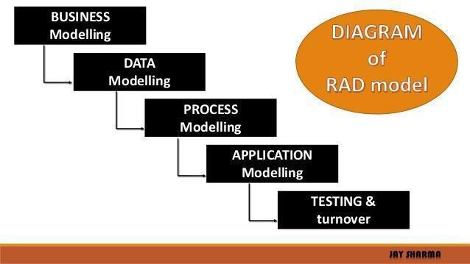

#### Figure: 4.6.1

**RAD Model Design**

RAD model distributes the analysis, design, build and test phases into a series of short, iterative development cycles.

Following are the various phases of the RAD Model −

### Business Modelling

The business model for the product under development is designed in terms of flow of information and the distribution of information between various business channels. A complete business analysis is performed to find the vital information for business, how it can be obtained, how and when is the information processed and what are the factors driving successful flow of information.

### Data Modelling

The information gathered in the Business Modelling phase is reviewed and analysed to form sets of data objects vital for the business. The attributes of all data sets is identified and defined. The relation between these data objects are established and defined in detail in relevance to the business model.

### Process Modelling

The data object sets defined in the Data Modelling phase are converted to establish the business information flow needed to achieve specific business objectives as per the business model. The process model for any changes or enhancements to the data object sets is defined in this phase. Process descriptions for adding, deleting, retrieving or modifying a data object are given.

### Application Generation

The actual system is built and coding is done by using automation tools to convert process and data models into actual prototypes

### 5.SOFTWARE REQUIREMENT ANALYSIS

* 1. **Purpose:**

Online Canteen Automation System is a web Application where customers order their food and receive food in the canteen without any delay as they can directly go and collect what they ordered without waiting for a turn or waiting time. This system aims to accelerate customer orders and customer order system used by employees to accept customer order.

### Intendant Audience and Reading suggestions:

This document is intended for different types of readers such as canteen owner i.e. client, system design, system developer as well as tester. By reading this document a reader can learn about what the project is, methodology for the same. This document has a sequential overview of the whole project starting from introduction which includes sub parts such as purpose of the document, scope of the product being implemented, intended audience and many such related sub parts. The document further describes overall description of the product which covers sub topics such as perspective and functionality of the product, operating system characteristics supported by the system and includes some design and implementation constraints. The flow of the document then covers some functional and non-functional requirements of the system.

### Product Scope:

This system will help to manage and run the canteen business systematically. In this system customers can easily order their food. Feedback feature is also implemented so that customers can share their feedback through which the owner of the canteen can evaluate and make required changes to the system. All the information about daily expenses and profit will be saved in the system

### Overall Description

* + 1. **Product perspective**
* The Canteen Management System helps the canteen manager to manage the canteen more efficiently and effectively, by computerizing meal ordering, billing and inventory controls.
* The system, processes transactions and stores the resulting data that will help the manager generate reports in order to make appropriate business decisions for the canteen. For example, knowing the number of customers for a particular time interval, the manager can decide whether more chefs or waiters are required. Moreover, he can easily calculate the daily expenditure and profit.
* The whole management system is designed for a general Computerized, Digital Canteen.So that any canteen owner can use to start an automated process in his Canteen.
* Implementing this system will lead to hire less waiters and create an opportunity to appoint more chefs and better kitchen place to serve food faster. Customers can also make payment through debit and credit cards

### Product functions:

All of the functions will be performed in the order given below,

* Food order via app
* Confirm order
* Online Payment
* Serve food
* Available goods
* Customer information
* Customer review

### User classes and characteristics

The **OCMS** has three active actors and one cooperating system. The customers can

access the system using their smartphones to order food. The online payment portal is accessed by the customer to complete the payment transactions. The chef checks the order, and sends a confirmation once the customer has paid for his order. After this the chef starts preparing the food and tells the system if it’s ready. The customer can then go and collect the food from the collection counter. The admin can add or delete contents from the menu, edit the price, count total earnings and expenditure, and take feedback from the customer

### Operating Environment

The operating environment for this application is stated as below:

Operating system : ANDROID OS(mobile version)/WINDOWS7,8,10. Database :MySQL

IDE/Text Editor : Visual Studio Code

Browser : Any Browser chrome/edge/Firefox/safari.

### Design and implementation constraints

There are some constraints that cost the system a-lot. A barrier that once crossed can optimize the system to its best. Few such barriers are:

* IOS App, Android and Windows App
* Information flow or data flow can be controlled to be more effective
* Faster servers such as Linux can be used
* English language can be used for India
* C# can be used for more security.

### User Interfaces

* The **OCAS** screen displays shall conform to the Process Impact Internet Application User Interface Standard, Version 1.0.
* The system shall provide a help link from each displayed HTML page to explainhow to use that page.
* The Web pages shall permit complete navigation and food item selection using the keyboard alone, in addition to using mouse and keyboard combinations.

### 5.3.1Hardware Interfaces

### No hardware interfaces have been identified

### 5.3.2Software Interfaces

* The OCAS shall transmit the quantities of food items ordered to the CMS through a programmatic interface.
* The OCAS shall poll the OCAS to determine whether a requested food item is available.
* When the OCAS notifies the OCAS that a specific food item is no longer available,

the OCAS shall remove that food item from the menu for the current date.

### 5.3.3 Communication Interface

* The OCAS shall send an message to the customer to confirm acceptance of an order, price, and delivery instructions.
* The OCAS shall send an message to the admin to report any problems with the meal order or delivery after the order is accepted.

### 5.3.4Performance Requirements

For the better functioning of application, the concerned classes has to work efficiently in a control flow manner either both doesn’t made any delay in generating or notifying.

### 5.3.5 Safety & Security Requirements

If there is extensive damage to a wide portion of the database due to catastrophic failure, such as a disk crash, the recovery method restores a past copy of the database that was backed up to archival storage (typically tape) and reconstructs a more current state by reapplying or redoing the operations of committed transactions from the backed up log, up to the time of failure. Security systems need database storage just like many other applications. However, the special requirements of the security market mean that vendors must choose their database partner carefully.

### Software Quality Attributes

**Availability:** This application should be available for every valid

/registered Admin/Student/Product management.

**Correctness:** There should be perfection in selecting formats and generate for respective Product management only.

**Usability:** The application should satisfy maximum usage/generation of needs for multiple numbers of Shop Holders/Students.

**6.SYSTEM DESIGN**

### UML Diagrams

* Class Diagram
* Use case Diagram
* Activity Diagram

### Class diagram

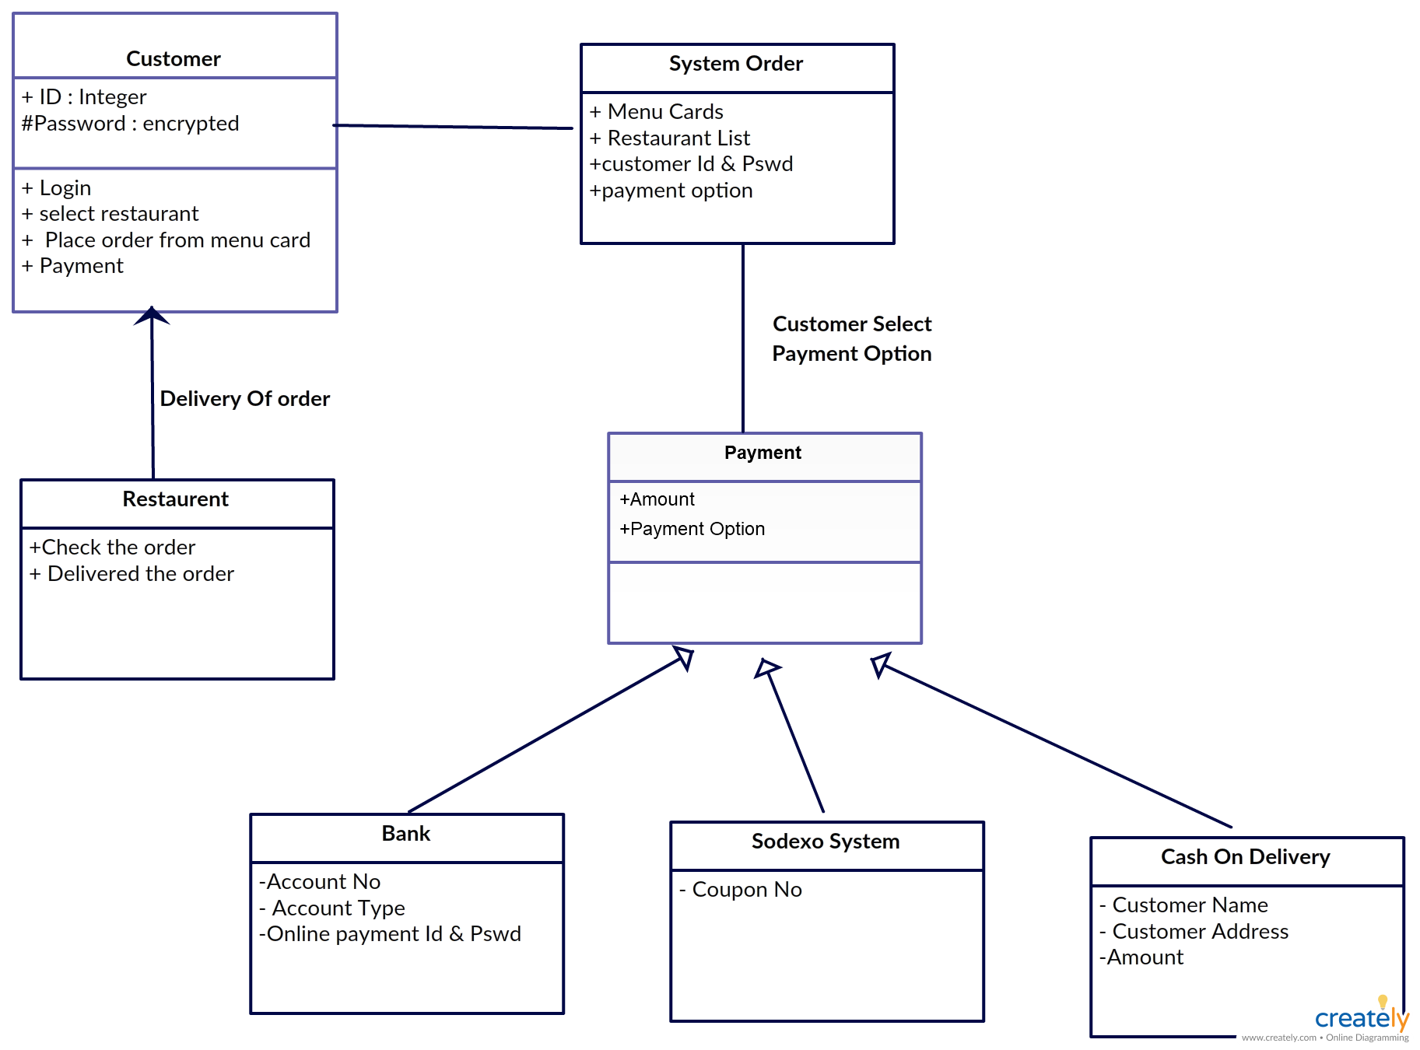

#### Figure: 6.1.1

### Use case diagram

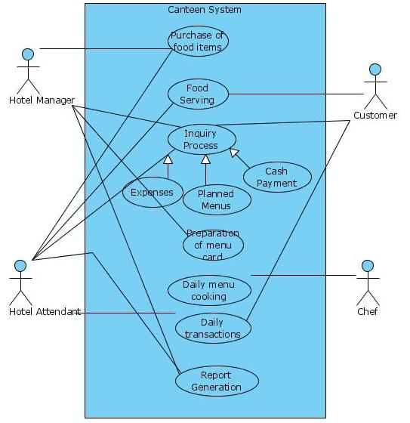

Figure: 6.1.2

### 6.1.3Activity Diagram

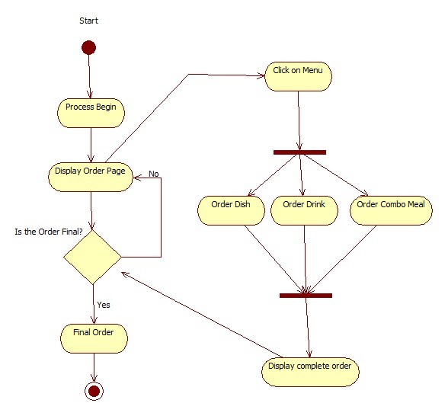

Figure: 6.1.3

### 7.SOFTWARE ENVIRONMEN

### The design of the site has been done using the following technologies:

* HTML, CSS
* PHP
* MySQL

**7.1 HTML: HYPER TEXT MARKUP LANGUAGE**

* In computing, Hypertext Markup Language (HTML) is a markup language designed for the creation of web pages with hypertext and other information to be displayed in a web browser. HTML is used to structure information denoting certain text as headings, paragraphs, lists and so on and can be used to describe, to some degree, the appearance and semantics of a document. HTML’s grammar structure is the HTML DTD that was created using SGML syntax.
* The HTML document format is used on the Web. Web pages are built with HTML tags (codes) embedded in the text. HTML defines the page layout, fonts, and graphic element as well as the hypertext links to other documents on the web. Each link contains the URL, or address, of a Web page residing on the same server or any server worldwide, hence “World Wide Web”.
* HTML 2.0 was defined by the Internet Engineering Task Force (IETF) with a basic set of features, including interactive forms capability. Subsequent versions added more features such as blinking text, custom backgrounds and tables of contents. However, each new version requires agreement on the tags used, and browsers must be modified to implement those tags. HTML is a mark-up language (the ML in HTML) that uses a fixed set of markup tags. A markup language can also be thought of as a “Presentation Language”, but it is not a programming language. You cannot “if this-do that” like you can in Java, JavaScript or C++.
* However, in order to make pages interactive, programming code can be embedded in an HTML page. For example, JavaScript is widely interspersed in Web pages (HTML pages) for that purpose. HTML was conceived as a simple markup language to render research documents. No one envisioned Web pages turning into multimedia extravaganzas. HTML pages have been reworked, jury-rigged and extended into full-blown applications.
* As a result, the source code behind today’s Web pages is often a hideous concoction of tags and scripting.

# CSS: CASCADING STYLE SHEETS

# Cascading Style Sheets (CSS) is a stylesheet language used for describing the look and formatting of a document written in a markup language. While most often used to change the style of web pages and user interfaces written in HTML and XHTML, the language can be applied to any kind of XML document, including plain XML, SVG, and XUL. Along with HTML and JavaScript, CSS is a cornerstone technology used by most websites to create visually engaging Webpages, user interfaces for web applications, and user interfaces for many mobile applications.

.

# 7.2 PHP: Hypertext Preprocessor

* PHP is a server-side scripting language designed for web development but also used as a general-purpose programming language. As of January 2019, PHP was installed on more than 5 billion websites (39% of those sampled) and 2.1 million web servers.2 Originally created by Rasmus Lerdorf in 1994, the reference implementation of PHP (powered by the Zend Engine) is now produced by The PHP Group.
* While PHP originally stood for Personal Home Page, it now stands for PHP: Hypertext Preprocessor, which is a recursive backronym code can be simply mixed with HTML code, or it can be used in combination with various templating engines and web frameworks.
* PHP code is usually processed by a PHP interpreter, which is usually implemented as a web server's native modular a Common Gateway Interface (CGI) executable. After the PHP codeis interpreted and executed, the web server sends resulting output to its client, usually in form of a part of the generated web page – for example PHP code can generate a web page's HTML code, an image, or some other data. PHP has also evolved to include a command-line interface (CLI) capability and can be used in standalone graphical applications.

**7.3MYSQL**

* Modern day websites seem to be relying more and more on complex database systems. These systems store all of their critical data and allow for easy maintenance in some cases. The Structured Query Language (SQL) is a very popular database language, and its standardization makes it quite easy to store, update and access data. One of the most powerful SQL servers out there is called MySQL and surprisingly enough, it’s free.
* Some of the features of MySQL Include Handles large databases, in the area of 50,000,000+ records. No memory leaks. Tested with a commercial memory leakage detector (purify). A privilege and password system which is very flexible and secure, and which allows host-based verification. Passwords are securesince all password traffic when connecting to a server is encrypted

**8.IMPLEMENTATION**

**8.1 Source code for updating cart in the website**

<?php

//if (session_status() !== PHP_SESSION_ACTIVE) {session_start();}

if(!isset($_SESSION))

{

session_start();

}

include 'connection.php';

$conn = Connect();

$F_ID = $_GET['id'];

$action = $_GET['action'];

$sql = "SELECT quantity FROM food WHERE F_id = ".$F_ID;

$result = mysqli_query($conn, $sql);

if($result){

if($obj = mysqli_fetch_assoc($result)) {

switch($action) {

case "add":

if($_SESSION['cart'][$F_ID]+1 <= $row["quantity"])

$_SESSION['cart'][$F_ID]++;

break;

case "remove":

$_SESSION['cart'][$F_ID]--;

if($_SESSION['cart'][$F_ID] == 0)

unset($_SESSION['cart'][$F_ID]);

break;

**8.2 Source code for Database Connection**

<?php

function Connect()

{

$dbhost = "localhost";

$dbuser = "root";

$dbpass = "";

$dbname = "ocas";

//Create Connection

$conn = new mysqli($dbhost, $dbuser, $dbpass, $dbname) or die($conn->connect_error);

return $conn;

}

?>

**9.SYSTEM TESTING**

**9.1 INTRODUCTION**

The purpose of testing is to discover errors. Testing is the process of trying to discover every conceivable fault or weakness in a work product. It provides a way to check the functionality of components, sub-assemblies, assemblies and/or a finished product. It is the process of exercising software with the intent of ensuring that the Software system meets its requirements and user expectations and does not fail in an unacceptable manner. There are various types of test. Each test type addresses a specific testing requirement.

Software system meets its requirements and user expectations and does not fail in an unacceptable manner. There are various types of test. Each test type addresses a specific testing requirement.

* All fields in every page are provided with required validations.
* Both username and password must be filled to login into a registered account.
* The values we enter are not secured in previous versions and now we have solved this problem.

**9.2 TYPES OF TESTS:**

**Unit testing:**

Unit testing involves the design of test cases that validate that the internal program logic is functioning properly, and that program inputs produce valid outputs. All decision branches and internal code flow should be validated. It is the testing of individual software units of the application .it is done after the completion of an individual unit before integration. This is a structural testing, that relies on knowledge of its construction and is invasive. Unit tests perform basic tests at component level and test a specific business process, application, and/or system configuration. Unit tests ensure that each unique path of a business process performs accurately to the documented specifications and contains clearly defined inputs and expected results.

• Checking validation as a part of unit testing for each page of website.

• The page navigates to another page only after each particular field of the page is filled with appropriate value.

**Integration testing:**

Integration tests are designed to test integrated software components to determine if they actually run as one program. Testing is event driven and is more concerned with the basic outcome of screens or fields. Integration tests demonstrate that although the components were individually satisfaction, as shown by successfully unit testing, the combination of components is correct and consistent. Integration testing is specifically aimed at exposing the problems that arise from the combination of components.

**Functional testing:**

Functional tests provide systematic demonstrations that functions tested are available as specified by the business and technical requirements, system documentation, and user man

Functional testing is cantered on the following items:

* Valid Input: identified classes of valid input must be accepted.
* Invalid Input: Identified classes of invalid input must be rejected.
* Functions : Identified functions must be exercised.
* Output : Identified classes of application outputs must be exercised.
* Systems/Procedures: interfacing systems or procedures must be invoked.

Organization and preparation of functional tests is focused on requirements, key functions, or special test cases. In addition, systematic coverage pertaining to identify Business process flows; data fields, predefined processes, and successive processes must be considered for testing. Before functional testing is complete, additional tests are identified and the effective value of current tests is determined.

**System Testing**:

System testing ensures that the entire integrated software system meets requirements. It tests a configuration to ensure known and predictable results. An example of system testing is the configuration oriented system integration test. System testing is based on process descriptions and flows, emphasizing pre-driven process links and integration points.

**White Box Testing:**

White Box Testing is a testing in which in which the software tester has knowledge of the inner workings, structure and language of the software, or at least its purpose. It is purpose. It is used to test areas that cannot be reached from a black box level.

**Black Box Testing:**

Black Box Testing is testing the software without any knowledge of the inner workings, structure or language of the module being tested. Black box tests, as most other kinds of tests, must be written from a definitive source document, such as specification or requirements document, such as specification or requirements document. It is a testing in which the software under test is treated, as a black box .you cannot “see” into it. The test provides inputs and responds to outputs without considering how the software works.

**9.3 Test objectives:**

• All field entries must work properly.

• Pages must be activated from the identified link.

• The entry screen, messages and responses must not be delayed.

**Features to be tested**

• Verify that the entries are of the correct format

• No duplicate entries should be allowed

• All links should take the user to the correct page

**10.SCREENSHOTS**

**Homepage**

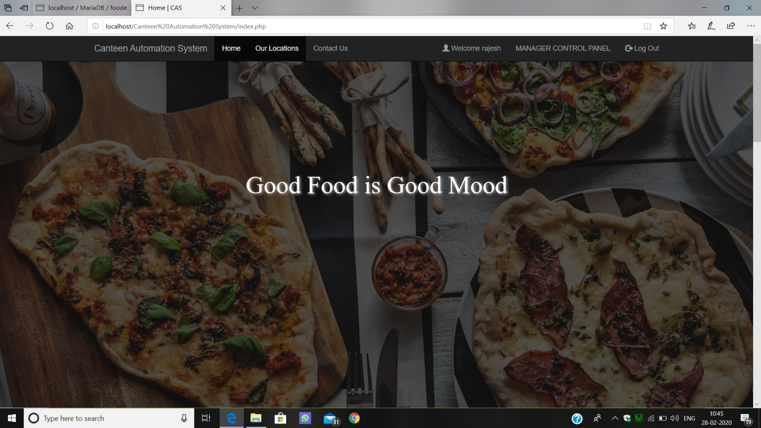

Figure 10.1

**Manager Control Panel**

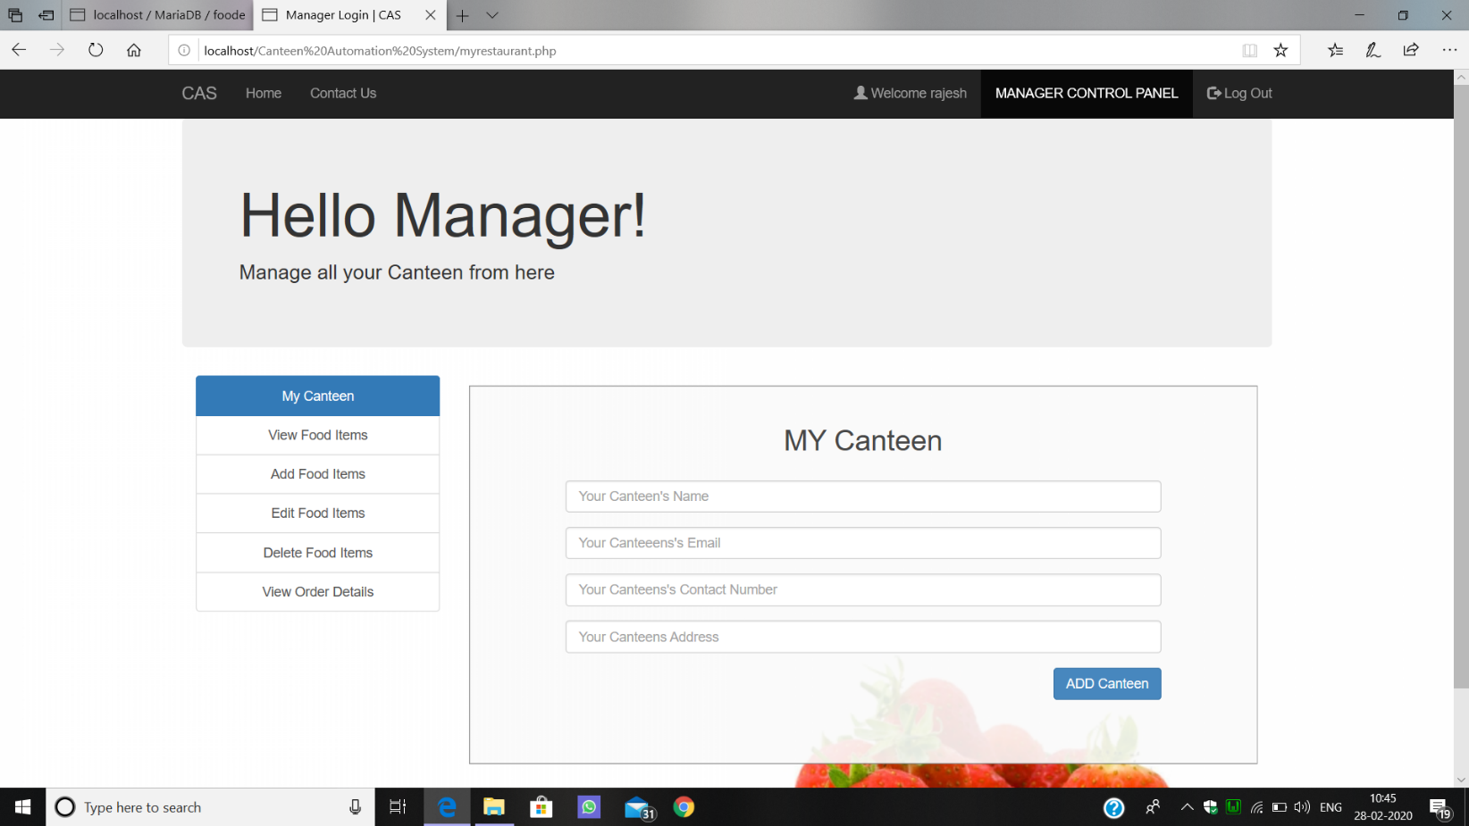

Figure 10.2

**Payment**

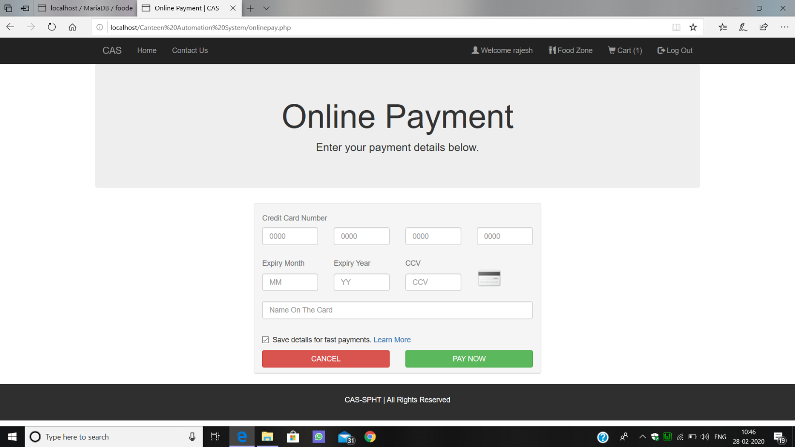

Figure 10.3

**Our Locations**

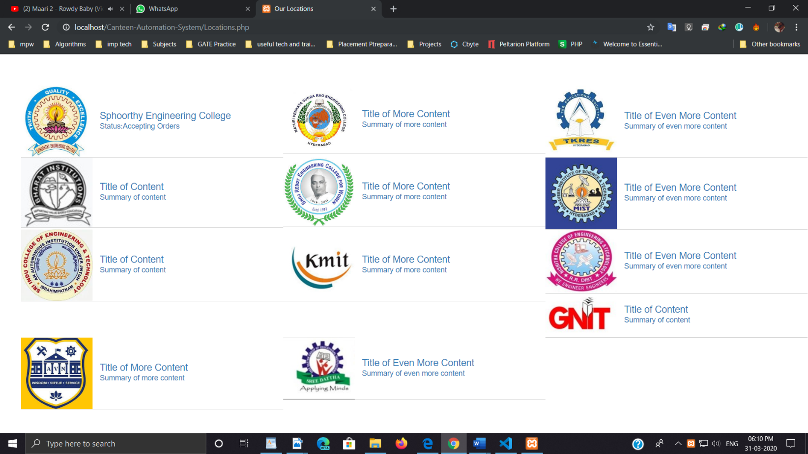

Figure 10.4

**Contact Us**

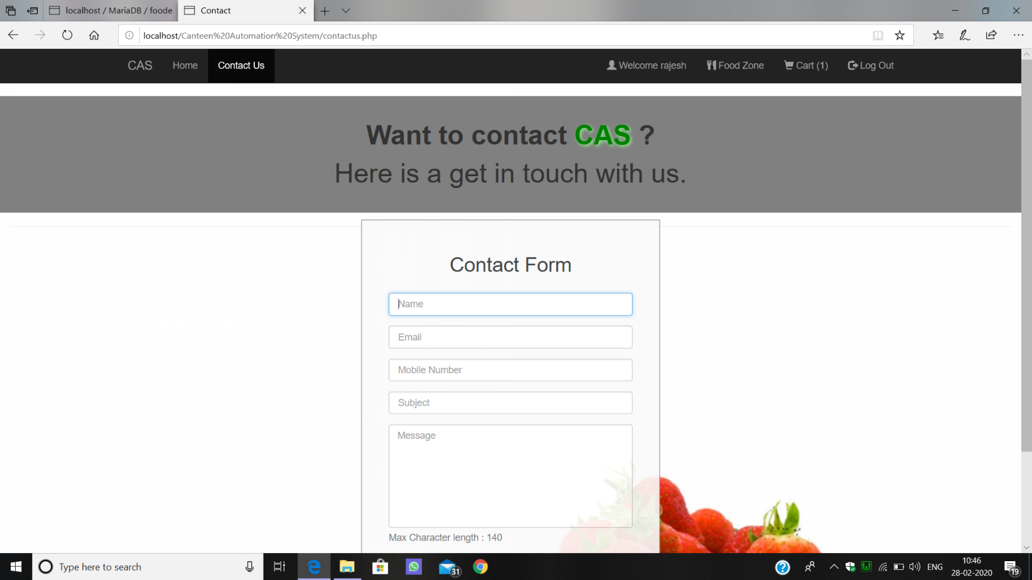

Figure 10.5

**11.CONCLUSION**

The development of Online Canteen Automation system involved many phases. The approach used is a top-down one concentrating on what first, then how and moving to successive levels of details.

The first phase started with a detailed study of the problems and prospects of ordering in Foods. In the course of this study, many problems were discovered to have hindered the effectiveness of the existing manual system. These problems, information needs and activities were documented and later used as the basis for system design, which immediately followed the first phase. The design phase was concerned primarily with the specification of the system elements in manner that best met the organization’s business needs.

During this phase, strict adherence was made on proven software engineering principles and practices. To implement this design, a computer program was then written and tested in server environment using tools.

it is hoped that effective implementation of this software product would eliminate many problems discovered during systems investigation.

**12.SCOPE FOR FUTURE DEVELOPMENT**

**13.BIBLIOGRAPHY**

**BOOK REFERENCE**

* Lynn Beighley & Michael Morrison (2008). Head First PHP & MySQL
* Robin Nixon (2010). Learning PHP, MySQL, JavaScript & CSS
* Ian Sommerville (2010). Software Engineering

**WEBSITE REFERENCE**

* www.google.com
* www.tutorialpoint.com
* www.w3schools.com

**OTHER REFERENCES**

* en.wikipedia.org
* Microsoft Developer Network (MSDN): http://msdn2.microsoft.com/en-us/default.aspx: This is a valuable online resource, and is a must for any developer using Microsoft tools.
* http://www.asp.net/: This is the official Microsoft ASP.NET web site. It has a lot of: tutorials, training videos, and sample projects.
* http://www.isr.umd.edu/Courses/BARAS-ENSE623/secured/Class%20Handouts/Trade-Off-1.pdf